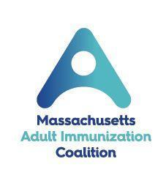
2022 Massachusetts Adult Immunization Champion
Nomination Form

The Massachusetts Adult Immunization Coalition (MAIC) is accepting nominations for its Massachusetts Adult Immunization Champion award. The annual award recognizes individuals or organizations that have made an outstanding contribution or effort to promote or foster adult immunization in Massachusetts.

The recipient will be an individual or an organization that has demonstrated particular leadership, initiative, innovation, collaboration and/or advocacy in promoting adult immunization. The award will be presented virtually at the 27th Annual Massachusetts Adult Immunization Conference on Tuesday, April 5, 2022. We will also feature the winner on the MAIC website.

Nominations should include:
- This completed nomination form
- Short bio, resume, or cv of nominee
- Sponsor statement

*Supplementary material may be included

Email your nominations to Amy Sgueglia at maic@jsi.com
by Friday, February 18th, 2022.

Adult Immunization Champion Nomination Form
Award Nominee Information
Submission Date:
Nominee’s Name:
Title and Organization of Nominee:
Address of Nominee:
Tel:
Email:

Sponsor Information (Nomination Submitted by)
Name:
Title and Organization:
Address:
Tel:
Email:

Sponsor’s Statement Describe the nominee’s contributions to adult immunization, including particular leadership, initiative, innovation, collaboration, advocacy, successes and/or challenges. It will help to provide concrete details and/or examples of activities and indicators of the impact. Specific evaluation data, if relevant, can be helpful too. (Maximum 250 words)

Nomination Deadline – Friday, February 18th, 2022

